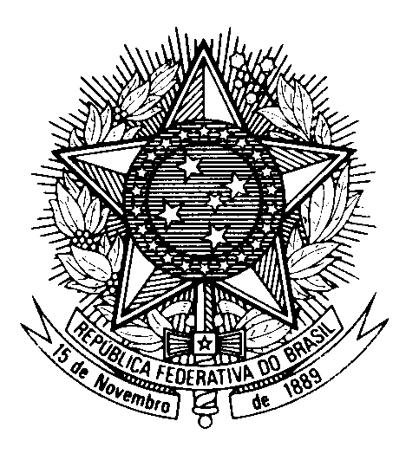

Statement by the Permanent Mission of Brazil to the United Nations Office in the review of Cambodia during the 46th session of the Working Group on the Universal Periodic Review

(Geneva, 8 May 2024)

Mr. President,

Brazil welcomes the delegation of Cambodia.

We commend the country for the significant advances in eradicating poverty.

We stress Cambodia`s progress in early childhood development and primary education, alongside initiatives aimed at encouraging girls to attend school.

In a constructive spirit, Brazil recommends Cambodia:

1) to adopt measures to enforce legislation on human trafficking and to develop and implement, in collaboration with international organizations and affected countries, protocols for the rescue and protection of victims; and

2) to take into consideration the right to privacy on its draft legislations about Internet, cyberspace and the digital environment.

We encourage Cambodia to incorporate mechanisms for consulting local communities and indigenous people, as well as to protect their rights related to their lands and to the resources of their territories.

Brazil wishes Cambodia a successful review.

I thank you.

(138 words)

