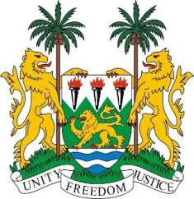

**SIERRA LEONE**

**46th Session of the UPR**

**REVIEW OF AFGANISTAN**

Monday, 29th APRIL 2024

**Check against delivery.**

**Mr. President**,

Sierra Leone welcomes and thanks **H.E Mr. Nasir Ahmed Andisha, Ambassador and Permanent Representative** and the distinguished delegation of the Islamic Republic of Afghanistan and thanks it for the presentation of its national report.

Sierra Leone remains deeply concerned about the state of the human rights architecture in Afghanistan, particularly following the dissolution of the Afghanistan Independent Commission and the Human Rights Support Unit by the de facto Taliban regime. Despite these challenges, however, we commend the Permanent Mission of the Islamic Republic of Afghanistan for its commitment to human rights principles, as demonstrated by its compliance with the Human Rights Council resolution and its decision to submit this national report to the Working Group.

We acknowledge the enormous constraints faced by the Mission in preparing this report, as well as the resilience demonstrated in overcoming these obstacles. The report provides a sobering and revealing picture of the current human rights situation in Afghanistan and highlights the pressing issues and challenges facing the Afghan people.

Deeply concerned by the deteriorating human rights situation in Afghanistan, Sierra Leone urges the following steps:

1. The defacto Taliban authorities grant the Special Rapporteur on Afghanistan and the Human Rights Section of UNAMA unfettered access to investigate, report, and document human rights violations.
2. That the international communityProvide technical and financial assistance to the Permanent Mission of Afghanistan in Geneva to effectively fulfill its obligations towards the Human Rights Council and its mechanisms.
3. That an independent investigative mechanism within the Human Rights Council be established to ensure thorough investigations and accountability for human rights violations in Afghanistan.

**Thank you, Mr. President.**