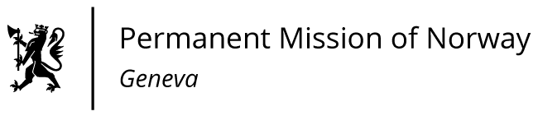

**STATEMENT**

**UPR 46 Session of the Human Rights Council**

**on the human rights situation in Afghanistan,**

**as delivered by Mr Tormod C. ENDRESEN**

**Ambassador - Permanent Representative to the UN and other International Organizations.   
The Permanent Mission of Norway in Geneva.**

Check against delivery

29 April 2024

President,

Norway welcomes the improved security situation in Afghanistan, but we remain deeply concerned about [discriminatory policies and practices that significantly impede gender equality, civic space, and access to justice]/ [ the human rights situation].

Norway recommends that Afghanistan:

1. revokes all discriminatory restrictions on girls’ schooling and ensures equal [and equitable] access to [quality] education.
2. takes concrete steps to [protect and] ensure women’s participation in economic, social and political life [in accordance with the Convention on the Elimination of all forms of Discrimination against Women].
3. respects the right to freedom of expression, movement and peaceful assembly and ensures that journalists, human rights defenders, and civil society can work [without risk of reprisals].
4. ensures access to justice for all Afghans by allowing judges and lawyers to work unhindered.

Thank you.