*Check against delivery*

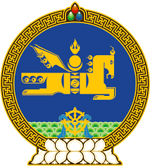

**46th SESSION OF THE UPR WORKING GROUP**

**MONGOLIA’S STATEMENT AT THE REVIEW OF AFGHANISTAN**

**29 April 2024, 14:30 - 18:00 hrs**

(1 min 30 sec)

Thank you, Mr. President.

Mongolia calls for the full, equal, meaningful, and safe participation of women and girls in all aspects of public life in Afghanistan.

We further encourage Afghanistan to promote a culture of human rights through human rights awareness-raising programmes and activities, including for law enforcement officials.

In the spirit of constructive engagement, Mongolia recommends Afghanistan to:

**One.** Ensure the participation of women and girls in education, vocational training and employment, in both the public and private sectors;

**Two.** End harmful practices against women and girls, including child marriages and forced marriages, and address and take further measures to prevent all forms of violence against women and girls;

**Three.** Ratify the Protocol to Prevent, Suppress and Punish Trafficking in Persons, Especially Women and Children, supplementing the United Nations Convention against Transnational Organized Crime, and the International Convention for the Protection of All Persons from Enforced Disappearances.

I thank you.

---oOo---