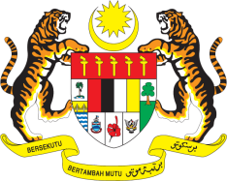

**STATEMENT BY MALAYSIA**

**REVIEW OF AFGHANISTAN**

**46TH SESSION OF THE UPR WORKING GROUP**

**29 APRIL – 10 MAY 2024**

Malaysia thanks Afghanistan for the presentation of its national report.

2. Malaysia closely monitors the situation in Afghanistan. We urge the international community to intensify efforts in providing humanitarian assistance, human capital development, and financial support to the people of Afghanistan.

3. In the spirit of constructive engagement, Malaysia recommends the following:

3.1. Continue working with the United Nations machinery, international organisations and other member states in providing access to all sectors of education for women and girls.

⁠3.2. Strengthen efforts to promote economic and social development by creating economic opportunities, providing basic necessities, and increasing participation in capacity building programmes offered by individual member states, regional and international community.

3.3. Ensuring that wherever possible, without delay, to ensure that there is equal access to education, healthcare services and basic necessities, particularly to the most vulnerable groups within the country, including those in the most rural areas.

4. We wish Afghanistan a successful review.

Thank you.

**29 APRIL 2024**

**GENEVA**