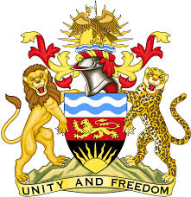

**REPUBLIC OF MALAWI**

**MALAWI STATEMENT ON AFGHANISTAN UNIVERSAL PERIODIC REVIEW**

**MONDAY, 29TH APRIL 2024**

**Mr. President**,

Malawi welcomes Afghanistan to this review and thanks the delegation for the comprehensive presentation.

In the spirit of constructive dialogue, Malawi makes the following recommendations:

1. Take all measures to promote and protect the rights of women and girls.
2. Take all measures to ensure girls access to education
3. Take all measures to end torture and other cruel, inhumane or degrading treatment.

We wish the Afghanistan all the best at this review and in the implementation of the recommendations.

**Thank you, Mr. President**.