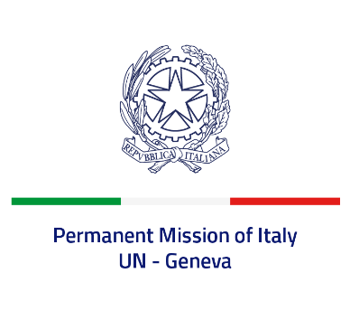

*Check against delivery*

**UPR 46 – Afghanistan**

**Monday 29 April 2024, 14:30 – 18:00**

**Delivered by: Permanent Representative of Italy Amb. Vincenzo Grassi**

*Thank you, Mister President*.

We thank the distinguished delegation of Afghanistan for their presentation and appreciate the efforts by the Permanent Mission of Afghanistan to prepare the national report in collaboration with civil society organizations and human rights defenders.

Italy would like to recommend to:

* *Ensure the full respect of the principles and obligations established by the UN Charter and all the other international treaties on human rights ratified by Afghanistan, including the Convention on the Elimination of All Forms of Discrimination against Women (CEDAW);*
* *Uphold the rights of women and girls, including full and equal access to education and work opportunities, lifting the bans currently in place;*
* *Establish a clear institutional and regulatory framework, including transparent judicial procedures, with equal rights and access for both men and women;*
* *Consider adopting a moratorium on the death penalty and provide official figures regarding death sentences and executions;*
* *In light of the reduction of international aid, allocate an appropriate share of the national budget to provide the Afghan people with critical services in sectors such as livelihoods, health, water and protection;*
* *Eliminate the severe restrictions imposed on the exercise of religious freedom and protect the country’s religious minorities from violence and discrimination;*
* *Protect the rights of children and take all necessary measures to end and prevent grave violations against them.*

We wish the delegation of Afghanistan a successful review. *I thank you*.