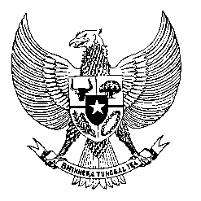

Permanent Mission

of the Republic of Indonesia to the UN, WTO,

and Other International Organizations

in Geneva

**STATEMENT BY THE DELEGATION OF THE REPUBLIC OF INDONESIA**

**AT THE 46th SESSION OF THE UPR WORKING GROUP**

**CONSIDERATION OF THE UPR REPORT OF AFGHANISTAN**

**29 APRIL 2024**

**Mr. Vice-President**

* Indonesia welcomes the participation of the delegation of Afghanistan in the 4th UPR cycle and appreciates them for presenting the report.
* It is deeply regrettable that after five years since its last UPR, we are seeing no human rights improvement in today’s Afghanistan.
* We particularly have grave concern with the continuing curtailment of the rights of Afghan women and girls through proliferation of restrictive laws on the access to education, work and public participation at large.
* Securing the rights of Afghan women is vital to achieving lasting peace and prosperity in Afghanistan.
* In that regard, Indonesia recommends that Afghanistan:
  1. Repeal all laws and policies that prohibit girls and women from enjoying secondary and higher education.
  2. Restore the rights of women to employment and meaningful participation in public and private sectors.
  3. Step up efforts to ensure more inclusive system of governance with equal representation of all Afghan society.
* To further support Afghan people in fully realizing their fundamental rights, Indonesia will continue its constructive engagement with Afghanistan, especially in humanitarian, education and religious fields.
* To conclude, we wish the Afghanistan delegation a very successful review.
* Thank you.

*Word counts: 191.*

*Time limit: 1 minute 30 seconds.*