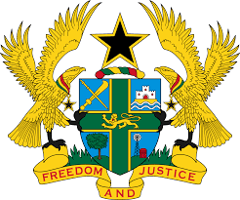

**STATEMENT DELIVERED BY GHANA DURING THE 46TH SESSION**

**OF THE UPR WORKING GROUP ON MONDAY, 29TH APRIL 2024**

**UNIVERSAL PERIODIC REVIEW OF AFGHANISTAN**

**Mr. Vice President,**

Ghana remains committed to a stable, secure and peaceful Afghanistan despite our deep concerns about reports of deteriorating human rights situation in the country.

2. As we have stated before, we urge the Taliban to reverse the discriminatory laws and policies imposed against girls, women and minorities, since it came to power in August 2021.

3. We recommend to Afghanistan to acknowledge that Afghan women and minorities are legitimate stakeholders of the country. They must be accorded every protection to enhance their effective participation in the country's reconstruction, future growth and development. It is therefore not in the interest of Afghanistan for any segment of its population to be excluded from the national reconstruction process. Such actions are counterproductive and denies the country of the contributions of all its citizens.

4. I conclude on a note of plea to the international community to stay steadfast in the provision of every necessary support required to address the needless suffering of the Afghan people.

5. Finally, we are convinced that a resurgent Afghanistan is in the best interest of the international community. We also believe that with active and constructive engagement, it is possible for Afghanistan to return to the international stage as a bona fide member of the comity of nations.

I thank you.