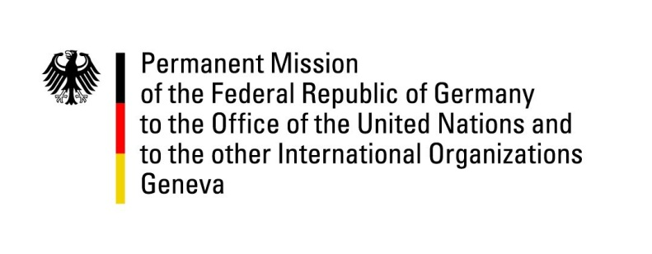

**United Nations Human Rights Council**

**46th Session of the UPR Working Group**

**Geneva, 29th of April 2024**

**German Recommendations and advance questions to**

**Afghanistan**

Mister President,

Germany welcomes the delegation of Afghanistan.

Germany strongly condemns the widespread violations of human rights committed by the de-facto authorities. Germany is deeply concerned about, in particular, the systematic and institutionalized gender-based discrimination and violence against women and girls. These actions may amount to ***systematic gender persecution***, which is recognized as a crime against humanity in the Rome Statute to which Afghanistan is a party. The Taliban are responsible for one of the most dire human rights situations worldwide.

Germany recommends Afghanistan to

1. take back all decrees limiting the fundamental rights and freedoms of women and girls guaranteed by international conventions to which Afghanistan is a party.
2. re-establish equal, inclusive, and equitable access to education without discrimination and in line with international standards.
3. take measures to prevent and investigate cases of violence against women and girls, to protect female victims, and to hold perpetrators to account.
4. investigate and bring to justice those responsible for violence against minority communities.
5. restore and protect the right to freedom of opinion and expression, and in particular to investigate cases of intimidation and attacks against journalists, human rights defenders, and civil society activists.

Thank you, Mister President.