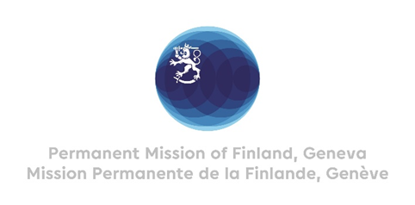

**46th Session of the UPR working group**

**Recommendations by Finland to Afghanistan**

**29th April 2024**

Mr. President,

Finland welcomes the engagement of Afghanistan in the UPR. We note with deep concern the developments since the last review. In the spirit of dialogue, Finland wishes to recommend:

1. One, to reverse laws, policies and practices that violate women’s and girls’ rights, including all forms of violence,
2. Two, to ensure accountability for human rights violations, including by ensuring that all forms of gender-based violence are criminalised,
3. Three, to prohibit all forms of discrimination on the grounds of disability, and guarantee equal and effective legal protection for the rights of persons with disabilities, especially women and girls,
4. Four, to protect ethnic and religious minorities, and to reverse laws, policies and practices that discriminate against them.

I thank you.