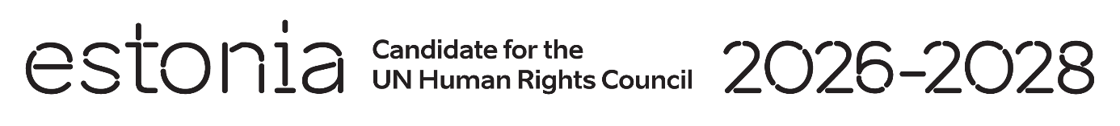

**Universal Periodic Review of the Islamic Republic of Afghanistan**

**29 April 2024**

**Intervention by the delegation of Estonia**

Estonia thanks Afghanistan for the engagement in the UPR process and for the information provided today.

We are deeply concerned by the discriminatory edicts, decrees and directives issued since August 2021 that violate human rights and target especially women and girls. These severe restrictions serve to exclude women and girls from work, education, healthcare, and to a large degree from public life. We urge Afghanistan to ensure that any law review complied with the obligations under international human rights law and restore public institutions and the rule of law in the country.

We would like to recommend to:

* remove all restrictions of and barriers to the rights of women and girls;
* accelerate progress regarding fighting gender-based violence, including domestic violence against women and girls;
* ensure equal access to quality education for all children, including improving access to education for girls at all levels in all regions of the country;
* establish a moratorium on executions;
* ratify the Second Optional Protocol to the International Covenant on Civil and Political Rights, aiming at the abolition of the death penalty.

Estonia wishes Afghanistan a successful review meeting.

Thank you.