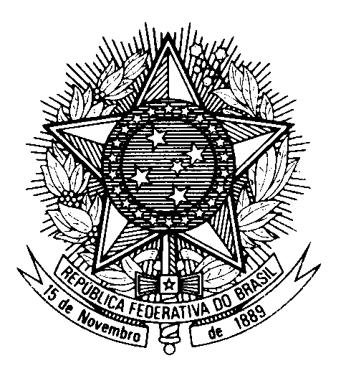

Statement by the Permanent Mission of Brazil to the United Nations Office in the review of Afghanistan during the 46th session of the Working Group on the Universal Periodic Review

(Geneva, 29 April 2024)

Mr. President,

Brazil reiterates its understanding that the UPR stands as a cornerstone in the global human rights framework, fostering accountability, transparency, and dialogue among nations. It is crucial that all States engage actively in this exercise, ensuring comprehensive scrutiny of human rights records every four years.

In light of Afghanistan obligations under international human rights law, we express our concern over reports of summary executions, arbitrary detentions, torture and arbitrary arrests, gender discrimination and violence and the shrinking of civic space, particularly against women and girls, human rights defenders, journalists and persons belonging to ethnic, religious and other minority groups.

Brazil recommends that Afghanistan:

1) bring an end, without delay, to all violations against women and girls´ most fundamental rights and freedoms, and rescind all discriminatory edicts and instructions issued since August 2021 that specifically target women and girls;

2) safeguard the rights of religious minorities in the country so that their members be allowed to practice their faith freely and peacefully, preventing any forms of harassment, persecution, or imprisonment.

I thank you.

(174 words)

