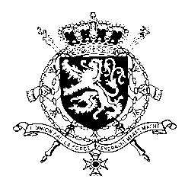

*Représentation permanente de la Belgique auprès des Nations Unies et auprès des institutions spécialisées à Genève*

|  |
| --- |
| **WG UPR – Afghanistan**  ***Belgian intervention***  29 April 2024 |

President,

Belgium deplores the dramatic human rights situation in Afghanistan and urges the *de facto* authorities in Afghanistan to:

**R.1.** Immediately repeal all edicts, policies, and directives that curtail human rights, in particular those limiting press freedom.

**R2**. Ensure women’s active participation in all aspects of public and political life and desist from committing threats or acts of violence, including arbitrary detention, sexual abuse, or any form of torture, ill-treatment or punishment against women and girls for allegedly violating the edicts or for protesting peacefully.

**R3.** Ensure that all children and youth, boys and girls, can access quality education at all levels and that schools are free from violence, threats, closures, and attacks.

**R4.** Adopt concrete measures to end and prevent all grave violations against children, in particular the recruitment and use of children, killing and maiming of children, attacks on schools and hospitals, and the denial of humanitarian access to children.

Thank you.