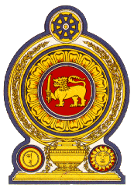

45th Session of the Universal Periodic Review

**Review of Senegal** – 22nd January 2024

Statement by the Democratic Socialist Republic of Sri Lanka

**Time Limit: 1 minute**

Mr. President,

Sri Lanka warmly welcomes the delegation of Senegal and appreciates the presentation made.

Sri Lanka commends the measures taken by Senegal since its last UPR towards converting the former national unit to combat human trafficking to the level of a committee to enable the prevention of trafficking in persons, migrant smuggling and forced begging and the establishment of a victim and witness assistance fund.

In a constructive spirit, Sri Lanka recommends that Senegal;

1. Continues the work of the National Advisory Council on Human Rights and International Humanitarian Law to prepare reports and monitor the implementation of international humanitarian law and recommendations made by international human rights bodies.
2. Continue to promote and provide funding to women’s entrepreneurship efforts.
3. Step up efforts to bridge the gap in education between schools in the major cities and those in rural areas.

We wish Senegal success in its UPR engagement.