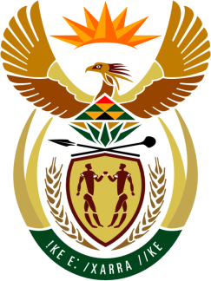

**SOUTH AFRICAN PERMANENT MISSION**

**TO THE UNITED NATIONS**

**AND OTHER INTERNATIONAL ORGANISATIONS**

**45th SESSION OF THE WORKING GROUP ON THE**

**UNIVERSAL PERIODIC REVIEW**

**Review of SENEGAL**

**22 JANUARY 2024**

**(60 Seconds)**

**speaker no: 43**

***Check against delivery***

Mr. President,

South Africa welcomes the distinguished delegation of Senegal to this UPR Session and wishes the country a successful review.

My delegation commends the strides made by Senegal since the last review including the adoption of the National Strategy for the Eradication of Female Genital Mutilation (2022–2030), and the Action Plan against Forced Marriage (2022–2026).

South Africa wishes to respectfully recommend that Senegal:

1. Enhance the legislative and regulatory framework to enable the national human rights institution to be brought into line with the Paris principles;
2. Expedite the effective implementation of Article L.180 of the 1997 Labour Code that seeks to increase the employment of persons with disabilities.
3. Enhance efforts to adopt a Children’s Code in line with international standards

I thank you.