Jamhuuriyadda Federaalka Soomaaliya  Ergada Joogtada Soomaliyeed ee Qaramada Midoobey ee Geneva, Switzerland. | 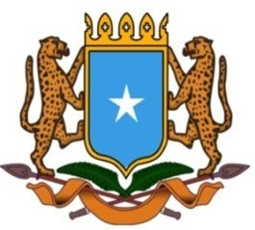 | جمهورية الصوما ل الفيدرالية  البعثة الدائمة لجمهورية الصومال بمكتب الأمم المتحدة بجنيف وبالوكالات المتخصصة بسويسرا

Permanent Mission of the Federal Republic of Somalia to the United Nations Office at Geneva and other International Organizations in Switzerland

Check Against Delivery
Statement by the Delegations of Somalia,
Hussen Abdi Musa, First Counsellor
at the Review of Senegal, during the 45th Session of the UPR Working Group on Monday, 22 January, 2024 from 14:30 to 18:00, in the Room XX of the Palais des Nations in Geneva, Speaker Number 42, Time: 1 minute and 00 seconds.

Thank you Mr. President,

Somalia warmly welcomes the distinguished delegation of the Republic of Senegal to this fourth cycle of the UPR working group and thanks them for their comprehensive national report as well as the update provided today. Somalia congratulates the Republic of Senegal for the great progress achieved in the area of human rights since last review.

Somalia commends the genuine commitment of the the Senegalese government to the UPR process and the several legal and institutional frameworks put in place, in order to promote economic, political and social development.

Somalia recommends the following:

1.Consider ratifying the ILO Migration for Employment Convention 1949 ( N0 97, as well as the ILO Domestic Worker Convention 2011 ( N0 189).
2. Continue implementing the National Strategy for the Eradication of Female Genital Mutilation 2022–2030 and related national action plan for the period 2022–2026.

Somalia wishes to the distinguished delegation of Senegal a successful outcome in this review.

I Thank you Mr. President.

