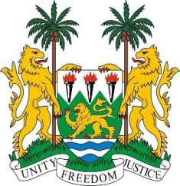

**SIERRA LEONE**

**45th Session of the UPR Statement**

**SENEGAL**

Monday, 22 January, 2024

***Check against delivery***

**Mr President**,

Sierra Leone welcomes **H.E Mrs. Aissata Tall Sall, Minister of Justice** and the distinguished delegation of Senegal and thanks them for the presentation of their national report.

My delegation commends Senegal for the measures taken to address prison conditions, including efforts to reduce overcrowding in its prisons through the adoption of Act No. 2020-28 of 7 July 2020, which introduced electronic monitoring as an alternative to detention, and the increase in the budget allocated to the National Observatory of Places of Deprivation of Liberty.

My delegation also welcomes Senegal's stated intention to accede to the Second Optional Protocol to the ICCPR and to abolish the death penalty.

In the spirit of constructive engagement, Sierra Leone offers the following recommendations.

1. Consider extending a standing invitation to all special procedures mandate holders and facilitate their access to the country.
2. Intensify efforts to regain the “A” status of the Senegalese Human Rights Committee by bringing it in line with the Paris Principles.
3. Raise the minimum age of marriage to 18 for both boys and girls.
4. Continue to review prison conditions with a view towards reducing overcrowding.

Sierra Leone wishes Senegal every success in the completion of its fourth review cycle.

Thank you, Mr President.