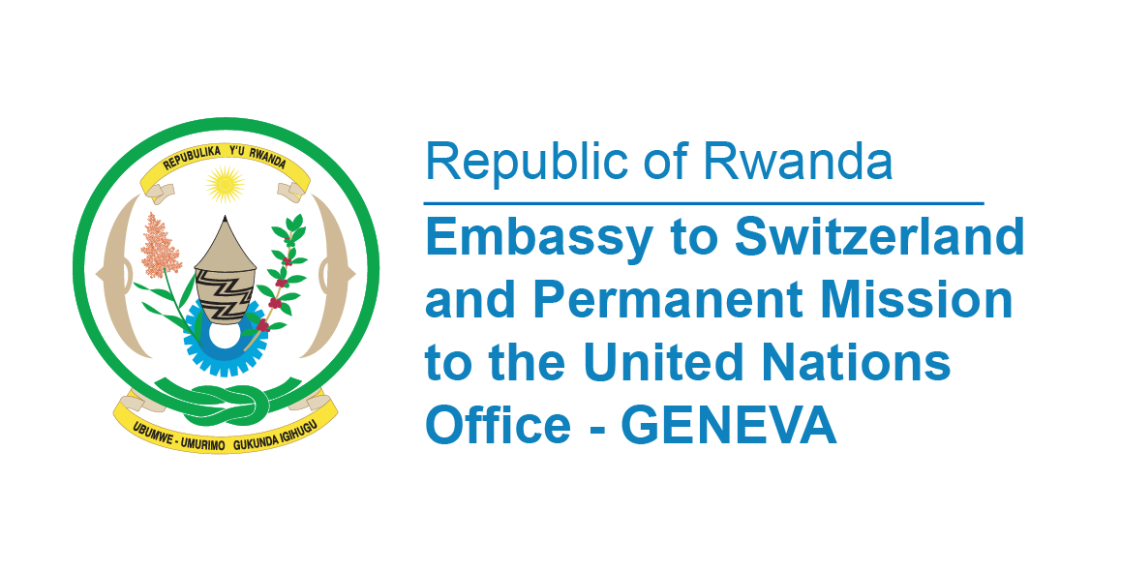

**45th Session of the UPR Working Group**

**Review of Senegal**

**22nd January 2024**

**Statement delivered by Ms Betty DUSENGE, Second Counsellor at the Permanent Mission of the Republic of Rwanda**

Thank you, Mr. President,

Rwanda warmly welcomes members of the delegation of Senegal and thanks them for the presentation of their National Report.

Rwanda commends the Government of Senegal for its equal opportunity strategy especially for people with disabilities by 2023 through national community-based rehabilitation programme.

Rwanda also notes with appreciation the adoption of a National Strategy for the Empowerment of Women and Girls for 2021–2025.

In the spirit of a constructive dialogue, Rwanda recommends to Senegal the following;

* Consider ratifying the Optional Protocol to the Convention on the Rights of the Child on a communications procedure.
* Strengthening the system for the protection of victims of gender-based violence and the adoption of a decree enhancing the protection of pregnant women.

Rwanda wishes Senegal a successful review.

**Thank you**