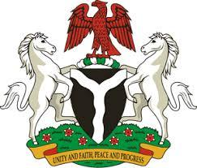

*Please check against delivery*

**HUMAN RIGHTS COUNCIL**

**45TH SESSION OF THE WORKING GROUP OF THE UPR**

**REVIEW OF THE REPUBLIC OF SENEGAL**

**22ND JANUARY, 2024**

**STATEMENT BY NIGERIA**

**Mr. President,**

Nigeria warmly welcomes the delegation of the brotherly Republic of Senegal and commends the Government for its continued cooperation with human rights mechanisms.

2. We further applaud the Government for the initiative adopted to protect and promote the rights of children, particularly through the “No Children on the Streets” Project.

3. While recognising the efforts and commitments of the Senegalese Government to promote and protect human rights, Nigeria wishes to recommend as follows:

1. To scale up efforts towards combating human trafficking, and ensure the protection of the rights of the victims of trafficking, particularly the children; and
2. To strengthen efforts to improve education for all children especially girls and children in rural areas.

4. Finally, we wish Senegal a very successful review process.

I thank you, Mr. President.