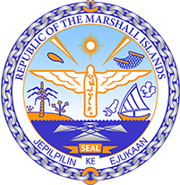

Republic of the Marshall Islands
STATEMENT by Mr. Samuel Lanwi Jnr
45th Session Universal Periodic Review
22nd January – 2nd February 2024
Geneva

4th Cycle Review of Senegal

The Marshall Islands welcomes the delegation of Senegal and thanks them for their report.

We commend Senegal for its steps to mitigate climate change, including the construction of solar energy plants and the introduction of greener public transportation. We also appreciate its plan to place more importance on environmental aspects in future programmes.

Additionally, we commend Senegal’s commitment to the Paris Principles and note its continuing challenge to bring the Senegalese Human Rights Committee in line with such Principles.

In a spirit of constructive dialogue, we recommend the following:
- Continue passing legislation such as Act No. 2020-08 in order to mitigate the effects of climate change.
- Align the Senegalese Human Rights Committee with the Paris Agreement by following up with the General Secretariat of the Government on the amendment of the law establishing said Committee.
- Adopt a law on the protection of human rights defenders.

We wish the delegation every success during its 4th UPR cycle.

Kommol tata and I thank you Mr. President.

