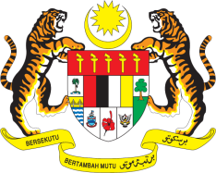

**STATEMENT BY MALAYSIA**

**REVIEW OF SENEGAL**

**45TH SESSION OF THE UPR WORKING GROUP**

**22 JANUARY – 2 FEBRUARY 2024**

Malaysia thanks Senegal for the presentation of its national report.

1. Malaysia congratulates Senegal’s efforts to enhance the wellbeing and protection of women and children, particularly in the field of health, education and socio-economy.
2. In the spirit of constructive engagement, Malaysia recommends the following:
   1. First, continue efforts to align Senegal’s legislation to ensure that women and girls have access to education, including high quality and secondary education;
   2. Second, take effective measures to monitor and evaluate the implementation of the existing strategies to eliminate disparities between women and men in the political, economic and social spheres such as the Senegal Digital 2025 and the National Equity and Gender Equality Strategy; and
   3. Third, step up efforts to develop a policy on inclusive and special education for children with disabilities to enable them to fully enjoy their rights.

4. We wish Senegal a successful review.

Thank you.

**22 JANUARY 2024**

**GENEVA**