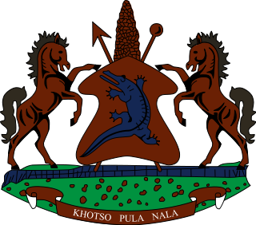

**INTERVENTION OF THE DELEGATION OF LESOTHO UNDER THE 4th UPR REVIEW OF SENEGAL**

**22 JANUARY 2024**

**GENEVA, SWITZERLAND**

**Thank you Mr. President,**

Lesotho welcomes the distinguished delegation of Senegal to the 4th cycle of their UPR review. We commend Senegal for taking positive steps to combat gender-based violence in the country, by developing and implementing a series of policies and strategies such as the National Equity and Gender Equality Strategy 2016–2026 among others. We further applaud the Government for addressing prison overcrowding and prolonged detention through the enactment of an Act which expands options for alternative sentences.

The above notwithstanding, Lesotho is cognisant of some of the challemges that hinder the full emjoyment of the human rights in the country and therefore wishes to make the following 3 recommendations for consideration by Senegal. 1. To beef up efforts to prevent torture and other forms of ill-treatment in police custodies and other places of detention; 2. to extend standing invitations to all UN Special Procedure mandate holders; and lastly, to strengthen measures to ensure access to education to women and girls in the rural areas.

Finally, we wish Senegal every success with this UPR cycle.

**THANK YOU**