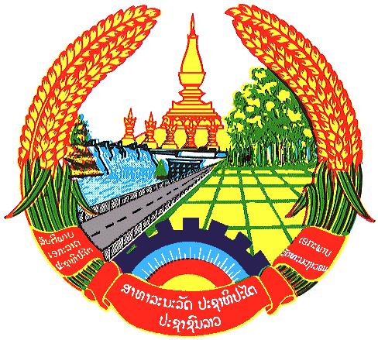

**Statement by the delegation of the Permanent Mission of the Lao PDR to the United Nations and other International Organizations in Geneva**

**at the 45th Session of UPR Working Group**

**Geneva, 22 January 2024**

(Speaking time 01 minute)

Review of Senegal (14:30 - 18:00)

1. Thank you, Mr. President, for the floor.
2. My delegation warmly welcomes the delegation of Senegal and thanks for the presentation of the national report.
3. The Lao PDR commends Senegal’s concrete efforts in developing national legal and institutional frameworks to promote and protect human rights. We also welcome the progress made in increasing women’s representation in the parliament.
4. The Lao PDR would like to make the following recommendations:

* Continue efforts to ensure equal access to quality education for all children; and
* Strengthen the implementation of the National Health and Social Development Plan 2019-2028 to realizing universal access to healthcare services.

1. We wish Senegal every success in this UPR cycle review.
2. I thank you, Mr. President.