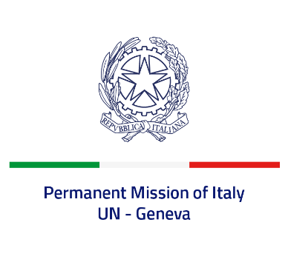

*Check against delivery*

**UPR 45 - Senegal**

**Monday 22 January 2024, 14:30 - 18:00**

**Delivered by: Ambassador Vincenzo Grassi, Permanent Representative of Italy**

Thank you, Mister President.

We thank the distinguished delegation of Senegal for its national report and presentation.

Italy recognizes the steps taken by Senegal to protect women’s rights, including the amendment of the Criminal Code in order to criminalize rape and the strengthening of the system for the protection of victims of gender-based violence. Nonetheless, we remain concerned by the persistence of harmful traditional practices against women and girls.

Italy seizes this opportunity to offer Senegal the following recommendations:

* *Continue the efforts to end all forms of violence against women and girls, in particular female genital mutilation;*
* *Raise the minimum legal age of marriage to 18 years for girls to eradicate child marriage;*
* *Strengthen the efforts in combating child exploitation to reduce the practice of forced child begging.*

We wish Senegal a successful review.

I thank you.