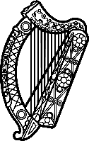

**Statement of Ireland**

**45th session of the UPR Working Group**

Review of Senegal

**22nd January 2024**

Ireland thanks the delegation of Senegal for its presentation today.

Ireland welcomes Senegal’s efforts to advance human rights since the last UPR cycle particularly in the area of women’s political participation. We encourage further efforts to ensure the effective application and full implementation of the Parity Act.

Ireland regrets that progress has not been made in revising article 319 of the Criminal Code to address the persecution of persons on the basis of their sexual orientation or gender identity.

Ireland recommends that Senegal:

1. Guarantee and respect the right of assembly and demonstration of the general public, politicians and civil society organizations;
2. Ensure the independent investigation of harassment, intimidation, hate speech and threats against journalists, political opponents and human rights defenders, and ensure prosecution of the perpetrators.

We wish Senegal every success in this UPR cycle. Thank you.