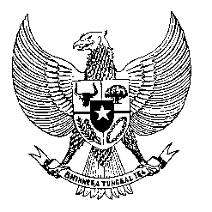

Permanent Mission

of the Republic of Indonesia to the UN, WTO,

and Other International Organizations

in Geneva

**STATEMENT BY THE DELEGATION OF THE REPUBLIC OF INDONESIA**

**AT THE 45th SESSION OF THE UPR WORKING GROUP**

**CONSIDERATION OF THE UPR REPORT OF SENEGAL**

**22 JANUARY 2024**

**Thank you Mr. Vice President**

* Indonesia extends its appreciation to Senegal for its ongoing efforts in the field of human rights.
* We note the legislative advancements Senegal has made since its last UPR.
* Furthermore, Indonesia recognizes the efforts to align the Senegalese Human Rights Committee with the Paris Principles, following our delegation's recommendation at the 3rd UPR cycle.
* In a constructive spirit, we recommend Senegal to:

1. Strengthen efforts in gender equality and women's empowerment through more comprehensive programs on education and literacy in rural areas;
2. Further increase the resources for its human rights institutions to ensure effective oversight and implementation of human rights policies and norms.
3. Strengthen measures against child trafficking and exploitation through enhancing legal frameworks and expanding public awareness campaigns.

* To conclude, we wish Senegal a successful UPR.
* **Thank you.**