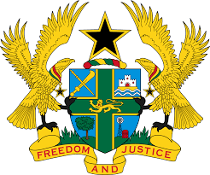

**STATEMENT BY GHANA DELIVERED BY H.E. EMMANUEL ANTWI, AMBASSADOR AND PERMANENT REPRESENTATIVE, DURING THE 45TH SESSION OF THE UPR WORKING GROUP ON MONDAY, 22ND JANUARY, 2024**

**UNIVERSAL PERIODIC REVIEW OF SENEGAL**

Madam Vice President.

Ghana welcomes the delegation of Senegal, and thanks them for the presentation of their national report.

We commend efforts made by Senegal in recent years to promote and protect human rights. We note in particular, the establishment of the National Advisory Council on Human Rights and International Humanitarian Law in 2018. We also welcome strategic efforts made to empower women in the country.

To further strengthen human rights in Senegal, Ghana recommends that:

1. **Senegal continues to take measures to ensure the prohibition of Female Genital Mutilation and Child Marriage;**
2. **Continue to strengthen its legal framework for the protection of women’s rights and promotion of gender equality; and**
3. **Continue efforts to strengthen national system to combat gender-based violence and bring perpetrators to justice.**

Ghana wishes Senegal every success with the review process.

I thank you.