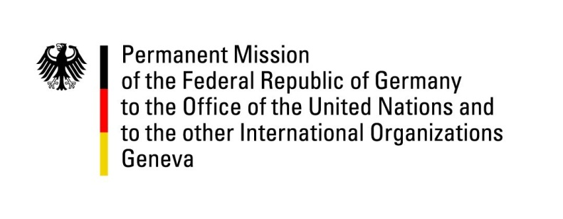

**United Nations Human Rights Council**

**45th Session of the UPR Working Group**

**Geneva, 22nd of January 2023**

**German Recommendations and advance questions to**

**Senegal**

Mister President,

Germany welcomes the delegation of Senegal.

Germany commends Senegal for adopting Law 2020-05, extending maximum sentences for rape.

However, Germany remains very concerned about persistent patterns of gender-based violence, including on the grounds of sexual orientation and gender identity, as well as recent developments concerning freedom of the press.

Germany recommends to:

* Establish effective procedures to investigate cases of gender-based violence, prosecute perpetrators and provide victims with medical care, psychosocial support and rehabilitation services and enable safe abortions without risk of criminal sanctions;
* Remove any provisions from the Family Code that allow for the discrimination of women in law or in practice, including articles 152 and 277;
* Repeal any provisions from the Criminal Code that give rise to violence and discrimination based on sexual orientation and gender identity, including article 319;
* Effectively investigate, prosecute, sanction and redress human rights violations committed during the 2023 protests.
* Strengthen efforts to ensure confidence in the respect of civil and political rights, including with regard to freedom of expression and the press.
* Adopt the draft Children’s Code aimed at bringing the protection of children’s rights into line with international standards .

Thank you, Mister President.