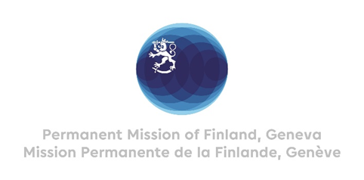

**45 Session of the UPR working group**

**Recommendations by Finland to Senegal**

**22nd January 2024**

Mr. President,

Finland welcomes Senegal’s engagement in the UPR process.

Finland welcomes the steps taken in Senegal to strengthen the realization of women’s and girls’ rights, for instance through the law criminalizing rape and pedophilia (2020) and the National Strategy (2022) to eliminate female genital mutilation.

Finland recommends:

1. First, to adopt the Children's code and take concrete measures to guarantee all children unconditional and free access to quality education, focusing especially on girls, children with disabilities and out-of-school children.
2. Second, to provide education on human rights, including sexual orientation and gender identity, to teachers, public officials and law enforcement actors,
3. Third, to bring Senegalese national legislation into line with international norms on freedom of expression and on the safety and protection of journalists.

I thank you.