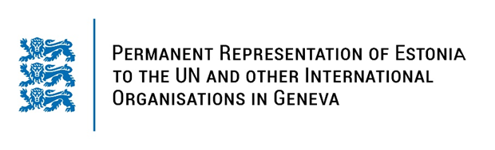

**Universal Periodic Review of Senegal**

**22 January 2024**

**Intervention by the delegation of Estonia**

Estonia warmly welcomes the delegation of Senegal to its fourth UPR. We thank Senegal for its national report and the information provided today.

We welcome the efforts of the Government of Senegal in the advancement of human rights, including the abolishment of death penalty in law and in practice. While noting the efforts of Senegal in the area of sexual and reproductive health, we encourage Senegal to take further steps with the aim to reduce maternal and neonatal mortality.

Estonia would like to offer the following recommendations to Senegal:

* strengthen administrative, legislative and judicial frameworks and mechanisms to eradicate the discrimination and violence against women and girls, in accordance with international human rights standards;
* ensure universal access to sexual and reproductive health information, counselling, education and services for all, in particular for adolescents;
* amend laws and policies to guarantee the freedom of expression, opinion and assembly;
* ratify the Second Optional Protocol to the International Covenant on Civil and Political Rights, aiming at the abolition of the death penalty.

Estonia wishes to the delegation of Senegal all success in the current review and in the implementation of the recommendations.

Thank you!