Jamhuuriyadda Federaalka Soomaaliya  Ergada Joogtada Soomaliyeed ee Qaramada Midoobey ee Geneva, Switzerland. | 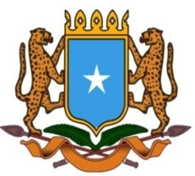 | جمهورية الصوما ل الفيدرالية  البعثة الدائمة لجمهورية الصومال بمكتب الأمم المتحدة بجنيف وبالوكالات المتخصصة بسويسرا

Permanent Mission of the Federal Republic of Somalia to the United Nations Office at Geneva and other International Organizations in Switzerland

Check Against Delivery
Statement by the Delegations of Somalia,
Mr. Hussen Abdi Musa, First Counsellor
at the Review of Saudi Arabia, during the 45th Session of the UPR Working Group on Monday, 23 January, 2024 from 14:30 to 18:00, in the Room XX of the Palais des Nations in Geneva, Speaker Number 131, Time: 00 and 55 seconds.
Thank you Mr. President,

Somalia warmly welcomes the delegation of the Federal Republic of Nigeria to this UPR session and thanks them for the comprehensive national report as well as the update provided today.

Somalia commends the government of Nigeria for its genuine commitment to the UPR process and the efforts made in implementing the recommendations of the previous cycles, in particular the measures taken to strengthen its legislation and policies with a view to improve the situation of human rights across the country.

In a spirit of constructive dialogue Somalia recommends the following :
1. Continue efforts aimed at combating poverty and female genital mutilation.
2. To take further measures to step up the fight against human trafficking and cross-border terrorism.
Somalia wishes Nigeria every success in this review.

I Thank you Mr. President.

