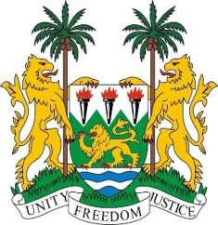

**SIERRA LEONE**

**45th Session of the UPR Statement**

**NIGERIA**

Tuesday, 23 January, 2024

***Check against delivery***

**Mr President**,

Sierra Leone welcomes and thanks **H.E Mr. Prince Lateef Fagbemi San, Attorney General of the Federation and Honourable Minister of Justice** and the distinguished delegation of Nigeria and thanks it for the presentation of their national report.

Sierra Leone commends Nigeria for the significant steps it has taken to advance the rule of law and strengthen the judiciary. These include the commendable development of a new National Justice Policy, the strengthening of the procedural systems through the enactment of the Administration of Criminal Justice Act and the successful implementation of the National Anti-Corruption Strategy.

In the spirit of constructive engagement, Sierra Leone offer the following recommendations.

1. Standardise the age of marriage in all states in order to eradicate child, early and forced marriage, both in law and practice.

1. Expedite efforts to establish a new national action plan on human trafficking.

1. Consider legislation or policy efforts to increase the participation of women in the political and public domains, particularly in decision-making positions.

Sierra Leone extends its best wishes to its sister, the federal Republic of Nigeria, for a successful review cycle.

Thank you, **Mr President**.