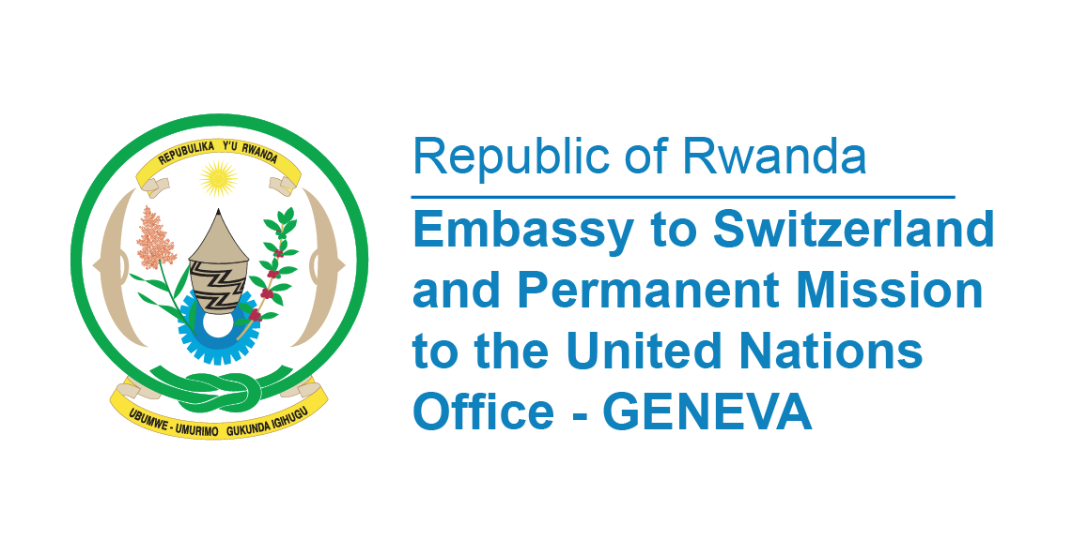

**45th Session of the UPR Working Group**

**Review of Nigeria**

**23rd January 202**

**Statement delivered by Ms. Betty DUSENGE, Second Counsellor at the Permanent Mission of the Republic of Rwanda**

Thank you, Mr. President,

Rwanda welcomes members of the delegation of Nigeria and thanks them for the presentation of their National Report.

We commend Nigeria’s efforts on combatting human trafficking by developing a five-year strategic policy framework andthe National Action Plan 2022-2026, to guide interventions and ensure efficiency in utilizing intervention funds in this regard.

Rwanda further appreciates the establishment of the National Social Investment Programme Agency Act, 2023, which informed the set-up of the National Social Investment Programme for equitable distribution of resources to vulnerable populations, including women, youths, and children.

**Rwanda recommends Nigeria to;**

* Consider ratifying the Second Optional Protocol to the International Covenant on Civil and Political Rights, aiming at the abolition of the death penalty;

Rwanda wishes Nigeria a successful review.

**Thank you**