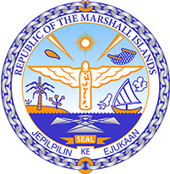

Republic of the Marshall Islands
STATEMENT by Mr. Samuel Lanwi Jnr
45th Session Universal Periodic Review
22nd January – 2nd February 2024
Geneva

4th Cycle Review of Nigeria

The Marshall Islands welcomes the delegation of Nigeria to this 4th UPR cycle. We commend Nigeria for passing the Climate Change Act and taking measures to implement the Paris Agreement, along with its active participation in global climate conferences.

We further commend Nigeria for the establishment of the National Oil Spill Detection and Response Agency to address the devastating impact of oil spills on the Niger Delta region. Such occurrences greatly affect the human rights of local populations and should be closely monitored.

In a constructive spirit, we offer Nigeria the following 2 recommendations:
- Implement the statement of the Human Rights Committee to promote transparency and accountability in the management of natural resources.
- Strengthen measures to support communities affected by oil spills in the Niger Delta in accordance with Nigeria’s previous support of such a recommendation.

We wish the delegation every success during its 4th UPR cycle.

Kommol tata and I thank you Mr. President.

