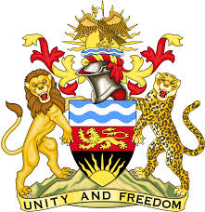

**REPUBLIC OF MALAWI**

**MALAWI STATEMENT ON THE DEMOCRATIC REPUBLIC OF CONGO UNIVERSAL PERIODIC REVIEW**

**TUESDAY, 30TH JANUARY 2024**

**Mr. President**,

Malawi welcomes the Federal Government of Nigeria to this review and we thank the delegation for the comprehensive presentation.

Malawi commends Nigeria for taking concrete steps in the promotion and protection of human rights. These include the adoption of the 5 P Strategy in combating trafficking in persons as well as policies to enhance gender equality and eliminate violence against women.

We make the following recommendations to Nigeria:

1. Continue taking all measures to increase the number of women in decision making positions.
2. Continue taking all measures to protect women and girls from sexual and gender violence.

We wish Nigeria all the best at this review and in the implementation of the recommendations.

**Thank you, Mr. President**.