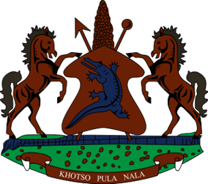

**STATEMENT BY THE KINGDOM OF LESOTHO DURING THE 4TH UPR REVIEW OF NIGERIA**

**23 JANUARY 2024**

**Thank you, Mr. President,**

Lesotho welcomes the distinguished delegation of Nigeria to the working Group and thanks them for the presentation of their Report. We commend the Government of Nigeria to promote and protect human rights of its citizens. Lesotho commend the government of Nigeria for the enactment of the Nigeria Data Protection Bill of 2023, whose purpose is to provide a legal framework for protecting and regulating personal data. We applaud Nigeria for complying with her treaty obligations by submitting State Party Reports before various UN treaty monitoring bodies.

Despite the progress made, Lesotho is cognisant of the challenges that Nigeria has been grappling with, in respect to the fulfilment of the human rights of her people and therefore in a constructive spirit, Lesotho recommends Nigeria to: 1. continue efforts to fight the plight of FGM, which continues to beset the country. 2. To redouble efforts to train and capacitate defence and security forces on the excessive use of force and 3. To bolster efforts to investigate acts of violence against women and girls, including domestic violence.

We wish to conclude by wishing Nigeria every success with the implementation of the recommendations emanating from this UPR cycle.

I THANK YOU