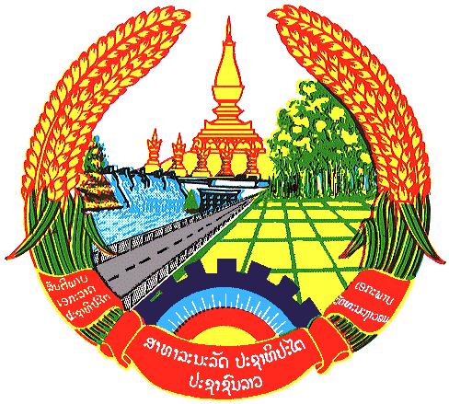

**Statement by the delegation of the Permanent Mission of the Lao PDR to the United Nations and other International Organizations in Geneva**

**at the 45th Session of UPR Working Group**

**Geneva, 23 January 2024**

(Speaking time 0.55 minute)

Review of Nigeria (14:30 - 18:00)

1. Thank you, Mr. President.
2. My delegation warmly welcomes the delegation of Nigeria and thanks for the presentation of the national report.
3. The Lao PDR commends Nigeria for taking positive steps to promote and protect human rights by developing national legislation and policy frameworks, including the adoption of the National Action Plan on Human Trafficking in Nigeria 2022-2026.
4. The Lao PDR would like to make the following recommendations:

* Strengthen the implementation of legislations and policies against trafficking in persons; and
* Continue effort to promote gender equality by creating favourable conditions for greater participation of women in decision-making process.

1. We wish Nigeria every success in this UPR cycle review.
2. I thank you, Mr. President.