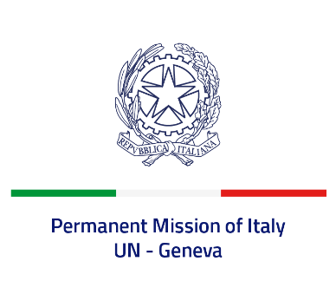

*Check against delivery*

**UPR 45 – Nigeria**

**Tuesday 23 January 2024, 14:30 – 18:00**

**Delivered by: Permanent Representative of Italy Amb. Vincenzo Grassi**

Thank you, Mister President.

We thank the distinguished delegation of Nigeria for their national report and presentation.

Italy appreciates the commitment of Nigeria to the UPR and the increased efforts to combat human trafficking.

Italy would like to recommend to:

* *Consider abolishing the death penalty*
* *Further intensify efforts to protect and promote the rights of children against all forms of violence and discrimination, including by preventing child, early and forced marriages and combating female genital mutilation*
* *Step up efforts to protect and promote freedom of expression, association and peaceful assembly in order to create a safe and favorable environment for human rights defenders, journalists and civil society*
* *Increase efforts to fight impunity by monitoring and investigating abuses by security forces.*

We wish the delegation of Nigeria a successful review.

I thank you.