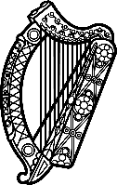

**Statement of Ireland**

**45th session of the UPR Working Group**

Review of Nigeria

**23rd January 2024**

Ireland thanks Nigeria for its presentation.

Ireland welcomes Nigeria’s efforts to advance human rights since the last UPR cycle, in particular the adoption of a national action plan for the promotion and protection of human rights.

However, Ireland remains concerned by the lack of accountability for human rights violations and abuses by a range of actors, including the security forces.

Ireland is also concerned by the persecution of LGBTQI+ persons and the continued criminalisation on the basis of sexual orientation and gender identity.

Ireland recommends Nigeria:

1. Ensure access to quality and evidence-based information and education about sexual and reproductive health.
2. Address recurring inter-communal violence by conducting impartial, comprehensive investigations into systematic attacks and bringing those responsible to justice, encouraging peacebuilding, and ensuring redress for victims and survivors.

Thank you.