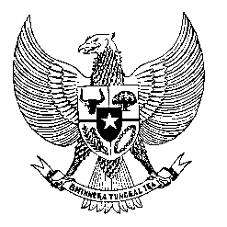

Permanent Mission

of the Republic of Indonesia to the UN, WTO,

and Other International Organizations

in Geneva

**STATEMENT BY THE DELEGATION OF THE REPUBLIC OF INDONESIA**

**AT THE 45th SESSION OF THE UPR WORKING GROUP**

**CONSIDERATION OF THE UPR REPORT OF NIGERIA**

**23 JANUARY 2024**

**Mr. Vice-President,**

Indonesia welcomes the delegation of Nigeria and thanks the Delegation for presenting the report.

We welcome Nigeria’s roles in peacekeeping and humanitarian efforts in the West Africa region.

We also note the efforts made to advance Nigeria’s criminal justice system, particularly on anti-corruption, anti-terrorism, and preventing police violence.

In a constructive spirit, Indonesia recommends:

1. Redouble efforts to address criminal acts, including banditry, kidnapping, and forced marriage.
2. Extend protection against violence based on ethnicity and religion.
3. Strengthen access to healthcare, particularly for children, women, persons with disabilities, and other vulnerable groups of people.

We wish Nigeria a successful review.

Thank you.

*Word Count: 105 words*

*Max. Speaking Time: 55 seconds*