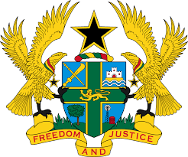

**STATEMENT BY GHANA DELIVERED BY H.E. EMMANUEL ANTWI, AMBASSADOR AND PERMANENT REPRESENTATIVE, DURING THE 45TH SESSION OF THE UPR WORKING GROUP ON TUESDAY, 23RD JANUARY, 2024**

**UNIVERSAL PERIODIC REVIEW OF NIGERIA**

Thank you, Mr. Vice President.

Ghana warmly welcomes the delegation of Nigeria to its UPR and commends the Government for its commitment to international human rights obligations and continued cooperation with human rights mechanisms.

We also commend Nigeria for the concerted efforts made to implement recommendations of the previous cycles, including the adoption of the national action plan for the promotion and protection of human rights and the National Policy on Women's Economic Empowerment.

In the spirit of constructive dialogue, Ghana recommends the following for the consideration of Nigeria;

1. **Continue its efforts to adopt the five Gender Bills from the previous assembly; and**
2. **Intensify efforts to declare an official moratorium on the death penalty, with a view to its future abolition.**

Ghana wishes Nigeria a very successful review process.

I thank you.