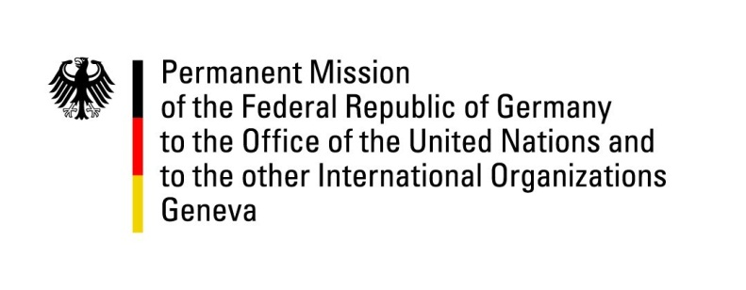

**United Nations Human Rights Council**

**45th Session of the UPR Working Group**

**Geneva, 23rd of January 2023**

**German Recommendations and advance questions to**

**Nigeria**

Mister President,

Germany welcomes the delegation of Nigeria.

Germany commends Nigeria for the 2015 passage of the Violence Against Persons Prohibition Act, as well as the subsequent domestication of the Act in almost all States of the Federation and the Federal Capital Territory (F.C.T.). The law greatly improves the legal basis for responding to violence against all persons, especially women and girls.

Further, Germany commends the 2020 passage of the Police Act, especially with regard to increased accountability within the police force. However, Germany remains concerned about the continued occurrence of human rights violations by security forces as well as the lack of adequate legal remedies for victims and their families.

In light of the yet incomplete domestication of the Child Rights Act to all States of the Federation, Germany is worried that the level of protection of child rights remains insufficient in Nigeria.

Germany recommends to:

* Ensure the passage of the five gender bills in the 10th National Assembly to increase women’s participation in politics in line with the Nigerian Government’s National Gender Policy (2006).
* Withdraw the Non-Governmental Organizations Regulatory Commission of Nigeria (Establishment) Bill.
* Decriminalize certain petty offences under existing Nigerian law, including loitering, vagabondry, hawking, alms begging, homelessness, sex work and disobedience to authorities.

Thank you, Mister President.