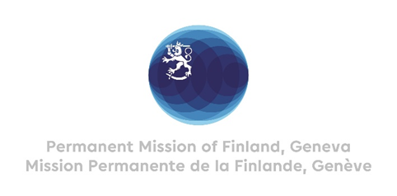

**44 Session of the UPR working group**

**Recommendations by Finland to Nigeria**

**23rd January 2024**

Mr. President,

Finland welcomes the engagement of Nigeria in the UPR process. We positively note Nigeria’s ratification of the ILO´s Violence and Harassment Convention (C190).

Finland recommends:

1. Firstly, to enforce the Child Rights Act (2003) in all states, including awareness creation and application of the law, and dispense justice to perpetrators without delay
2. Secondly, to take specific steps to promote, protect and fulfil women’s and girls’ rights, notably by enforcing the 2015 law banning all forms of violence against them across all remaining states.
3. Thirdly, to safeguard independence and pluralism of the media, and promote the full realization of freedom of expression and opinion, including on digital platforms.

I thank you.