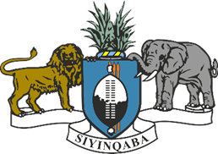

**STATEMENT BY THE KINGDOM OF ESWATINI ON THE REVIEW OF THE REPUBLIC OF NIGERIA**

**45TH SESSION OF THE UNIVERSAL PERIODIC REVIEW**

**23 JANUARY 2024**

The Kingdom of Eswatini extends a warm welcome to the distinguished delegation of the Republic of Nigeria to this review and thanks the delegation for the comprehensive update.

Eswatini commends Nigeria’s efforts in implementing recommendations from the third UPR cycle and congratulates Nigeria for the significant progress achieved in re-enforcing data protection laws through the Nigeria Data Protection Bill 2023.

In the spirit of constructive dialogue, Eswatini makes the following recommendations to Nigeria:

1. Ensure the effective implementation and enforcement of anti-trafficking legislation;

2. Continue ongoing efforts to prevent and eradicate female genital mutilation;

3. Translate the commitment made through the ratification of the Arms Trade Treaty into concrete actions

We extend our best wishes to the Republic of Nigeria for a successful review.