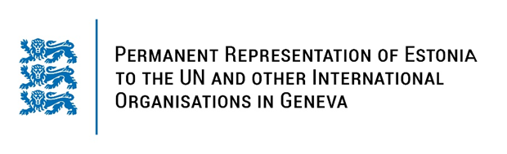

**Universal Periodic Review of Nigeria**

**23 January 2024**

**Intervention by the delegation of Estonia**

Estonia warmly welcomes the delegation of Nigeria to its fourth UPR. We thank Nigeria for its national report and the information provided today.

Estonia welcomes Nigeria’s national action plans on gender equality and women’s empowerment and we look forward to their full implementation. We encourage further efforts to protect and promote the rights of women and girls, including by ending harmful traditional practices.

Following up our previous recommendations, we would like to recommend Nigeria to:

* repeal discriminatory provisions and strengthen administrative, legislative and judicial frameworks and mechanisms to eradicate the discrimination and violence against women and girls and to promote gender equality;
* take steps to reduce the maternal and neonatal mortality rates;
* ensure universal and unimpeded access to sexual and reproductive health information, counselling, education and services, in particular for adolescents;
* ratify the Second Optional Protocol to the International Covenant on Civil and Political Rights, aiming at the abolition of the death penalty.

Estonia wishes to the delegation of Nigeria all success in the current review and in implementing the recommendations.

Thank you.