**Permanent Mission of the Democratic People's Republic of Korea to the United Nations Office and Other International Organizations in Geneva**

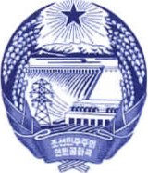

1. Chemin de Plonjon 1207 Geneva Tel: 022 735 4370 Fax: 022 786 0662

**Statement of the DPRK Delegation**

**on the 4th cycle UPR of Nigeria**

(45th session of UPR Working Group, 23 January 2023)

Mr. President,

The DPRK delegation welcomes the delegation of Nigeria and appreciates for its fourth national report.

We commend the Government of Nigeria for its efforts and progress in the promotion and protection of human rights by strengthening its legislative and institutional framework despite challenges.

We wish the Government of Nigeria further tangible progress in endeavour for full enjoyment of human rights by its people, and recommend the followings;

1. Continue to create an enabling environment for the improvement of public health system through national policies and funding.

2. Continue to ensure accessible and high-quality education for all.

We wish Nigeria successful review.

Thank you.