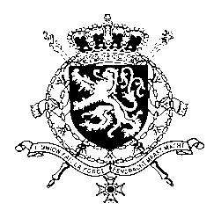
Représentation permanente de la Belgique auprès des Nations Unies et auprès des institutions spécialisées à Genève

WG UPR 45 – Nigeria
Belgian intervention
23 January 2024

President,
Belgium wishes Nigeria a constructive UPR and welcomes its recent adoption of a National Action Plan on Business and Human Rights.
We regret the lack of progress on the recommendations made during the previous cycle. Therefore, Belgium would like to recommend to:
R1. Implement safeguards against human rights violations by the civilian and military security forces and armed gangs, including arbitrary arrests and detentions, rape and other forms of torture, enforced disappearance, and extrajudicial executions.
R2. Ensure that the Child Rights Act is immediately domesticated in the two remaining states and ensure its effective implementation across Nigeria.
R3. End all forms of harassment, intimidation and attacks of journalists and human rights defenders, and ensure that the perpetrators of such acts are held accountable for their actions.
Thank you.

