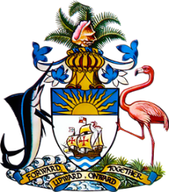

**Statement by Ms. Sasha Dixon, Counsellor  
Permanent Mission of The Bahamas to the United Nations Office and other International Organizations in Geneva**

**at the 45th Session of the Universal Periodic Review Working Group  
 *Presentation of National Report by the Government of Nigeria***

**23 January 2024**

Thank you, Madam/Mr. [Vice] President.

We welcome the delegation of Nigeria and thank the country for its comprehensive report, prepared through an inclusive national process.   
  
The Bahamas respectfully makes the following recommendations to Nigeria:

1. Accelerate efforts toward eradication of female genital mutilation, including through increased public education and awareness-raising campaigns;
2. allocate sufficient resources for the full implementation of the National Action Plan on Human Trafficking (2022–2026);   
     
   and
3. fully implement the revised National Social Protection Policy as a step toward development of a strong, inclusive and reliable social protection system

We commend Nigeria for progress made since the last review, such as efforts to improve access to quality education, including for out-of-school children; efforts to promote the empowerment of women and girls and steps toward the transition to a low-carbon, climate-resilient economy.

We wish the delegation every success in this UPR process.

Thank you.