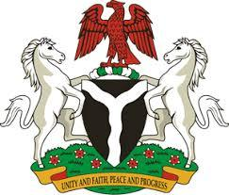

*Please check against delivery*

**HUMAN RIGHTS COUNCIL**

**45TH SESSION OF THE WORKING GROUP OF THE UPR**

**REVIEW OF THE MEXICO**

**24TH JANUARY, 2024**

**STATEMENT BY NIGERIA**

**Mr. President,**

Nigeria welcomes the delegation of Mexico to the presentation of its National Report and commends the Government for its commitment to international human rights obligations.

2. We further applaud the Mexican Government for efforts to advance the rights and fundamental freedom of its citizens, including through initiatives such as the National Development Plan and Human Rights training.

3. In the spirit of constructive dialogue, Nigeria wishes to recommend to Mexico as follows:

1. To scale up efforts to combat racism and discrimination in all its forms;
2. To redouble efforts to ensure the full enjoyment of human rights by people of African descent; and
3. To ensure that relevant laws and policies respect the rights and duties of parents or legal guardians of children, in accordance with international law

4. We wish Mexico a very successful review process.

I thank you, Mr. President.